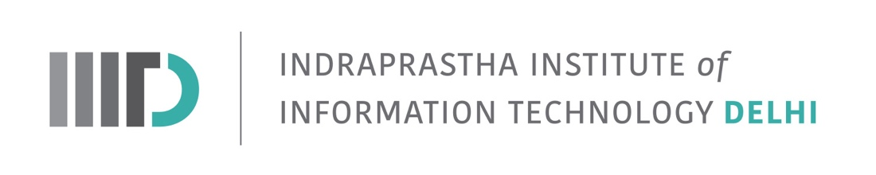
Invitation to M.Tech. Thesis Defense of Saurav Kumar Choudhary: May 20, 2022 Friday): 10:00 PM-11.00 PM IST

In Partial Fulfilment of the Requirements for the Degree of
M.Tech. CB
Saurav Kumar Choudhary (MT20216)
Will defend his thesis
Title: “Meta-pathway based analysis of stemness”
IIIT-D Faculty and Students are invited

Date: May 20, 2022 (Friday)
Time: 10.00 PM-11.00 PM IST
Online over Google meet (https://meet.google.com/zwc-beaa-puw?hs=224)

Examiner: Internal: N Arul Murugan
External/Internal: Arjun Ray
Advisor: Vibhor Kumar

*******************************************************
Abstract

Recent development in the stem cell research field has evoked great expectations. Researchers these days are full fledgedly working on developing methods to use self renewal potentials of stem cells in treating incurable diseases which can be a turning point in the field of modern medicine. Analysis of cells at cellular level (scRNA-seq) has given us power to explore activities happening inside the cell through gene expression. Here, we show how a slightly transformed data can provide better interpretability of results at low computational cost.These transformed data can be used to power ML algorithms with a small number of features. Pathways are better at explaining the process occurring inside a cell and therefore We aim to find a set of pathways as signature factors which are conserved across different stem cells. These can not only explain the functioning of a cell but also predict the state of a cell even with batch effects. We also showed how prediction scores of a ML model can be used to derive the biological insights from the datasets.

